BA723

Revision of BA706 Project

Predicting & Understanding Loan Defaults.

By -
Dev Desai - 301473593
Sherwin Dsouza – 301483113

Dataset:
Loan Default

Executive Summary
Lending has always been a business of trust — but in today’s data-driven world, trust alone isn’t enough. Financial institutions need to understand, with confidence, which borrowers are likely to repay and which ones pose a risk. That’s the challenge we set out to solve.
We started by asking a simple but crucial question: what separates someone who repays a loan from someone who doesn’t?
Looking at data from over a quarter-million past applicants, we uncovered patterns that went beyond credit scores. It wasn’t just about income or age — it was how these factors interacted with things like employment stability, interest rates, and even whether someone had a co-signer. Some of the findings were expected, others surprising, but all of them helped paint a fuller picture of borrower behaviour.
What came out of this work was more than just a model — it was a roadmap for smarter lending. Our best-performing solution, a neural network, quietly sorts through the complexity to flag high-risk applicants with remarkable accuracy. And for times when decisions need to be explained — to regulators, auditors, or customers — a simpler, transparent logistic regression model is ready to step in. Together, they give the bank a powerful edge: the ability to move fast, reduce risk, and make lending decisions that are not just smarter, but fairer too.

Business Context
For any financial institution, loan defaults represent one of the most critical threats to profitability and long-term stability. When borrowers fail to repay their loans, the institution faces not only direct financial losses but also growing risk exposure, reduced liquidity, and reputational damage. That’s why being able to predict loan default before it happens is not just useful — it’s essential.
This project is designed to help lenders make smarter, data-driven decisions by identifying which loan applicants are most likely to default. By analyzing past customer data, we’ve developed predictive models that can flag high-risk borrowers early in the loan approval process. These insights allow for better credit risk assessment and more responsible lending.
From a business standpoint, this opens up several key opportunities:
- Minimize losses: Reducing default rates directly improves financial performance.
- Improve portfolio quality: Filtering out high-risk loans strengthens the overall loan book.
- Optimize resource allocation: Time and capital can be focused on applicants with a higher chance of repayment.
- Enhance customer experience: Low-risk borrowers can benefit from faster approvals, while higher-risk applicants can be offered alternative solutions, such as lower amounts, secured products, or financial counselling.
In an increasingly competitive lending environment, having this level of risk visibility gives the institution a clear edge. It not only protects against downside risk but also supports sustainable growth. Our goal is to deliver a solution that doesn’t just detect risk — it helps you act on it confidently and proactively.

Methodology
To help the business make smarter lending decisions, we approached this project the way a strong risk advisor would — by asking the right questions and using data to back up every answer.
We began with a simple goal: to understand what separates a reliable borrower from one who’s likely to default. Looking at over 250,000 past loan applicants, we dug into patterns across income, age, employment status, credit scores, loan size, and more. The dataset gave us a full view of who these applicants were, and more importantly, how they behaved after getting approved.
As we explored the data, a few things stood out. Some categories were unnecessarily complex — for example, whether someone had a Master's degree or a PhD made little difference in their repayment behaviour. So, we simplified where it made sense. We also made sure that values like income were scaled in a way that didn’t distort the model's output. Throughout, we focused on keeping the data clean, intuitive, and aligned with real-world lending logic.
From there, we tested different ways to model risk. We started with logistic regression — a straightforward, transparent model that shows which factors increase or decrease the odds of default. This gave us early insights, like how a higher interest rate or lower credit score affects repayment risk.
But we didn’t stop there. We also looked at decision trees, which mimic how a credit officer might make yes-or-no calls based on applicant traits. And finally, we tested neural networks — a more sophisticated approach that can pick up on patterns that aren’t obvious at first glance. By adjusting the number of hidden nodes, we found that a slightly complex neural net gave us the best results in terms of predictive power, while still being stable and consistent.
To ensure our results were both accurate and explainable, we used a method called SHAP, which helped us visualize which features were truly driving each prediction. And when we noticed insights that could seem counterintuitive — like how having a co-signer might relate to default — we backed them up with statistical testing to confirm their significance.
In short, we didn’t just build a model — we built confidence in the model. We made sure that the numbers we present could be trusted, acted on, and explained to anyone in the room.

Key Insights
Once the models were built and tested, a few patterns became very clear — and they tell a compelling story about which types of borrowers are more likely to default, and why.
- Interest Rate, Income, and Credit Score are Major Signals
Borrowers facing higher interest rates were more likely to default. This suggests that applicants already perceived as high risk (and therefore charged more) may be even riskier than expected.
Similarly, lower-income applicants and those with weaker credit scores showed a much higher likelihood of missing payments. These findings align with industry expectations — but our model helps quantify exactly how much more likely these borrowers are to default, which makes it easier to build policies around them.
- Employment Stability Matters
Borrowers with longer work history — especially those employed full-time or self-employed — showed a lower risk of default. This insight supports the idea that consistent income over time is a stronger indicator of repayment ability than just a current income snapshot.
Interestingly, being unemployed at the time of application emerged as one of the top predictors of risk in both the regression model and SHAP analysis. This adds weight to the importance of verifying employment status as part of the approval process.
- Age and Loan Size Tell a Subtle but Important Story
Younger borrowers were slightly more likely to default than older ones. This isn’t a dramatic difference, but it suggests that maturity, financial literacy, or stability may play a small role in repayment behaviour.
Additionally, borrowers requesting larger loans tended to default more often — especially when loan size was not aligned with income. The takeaway? Loan sizing should always be stress-tested against realistic ability to repay.
- Co-signers and Dependents Have Unexpected Influence
One of the more surprising findings was that borrowers with a co-signer or dependents were actually less likely to default. While this may seem counterintuitive at first, it suggests that applicants with shared responsibilities or support systems might take repayment obligations more seriously. This insight was backed by a chi-square test, which confirmed the statistical significance of these patterns.
- Customer Segments with the Highest Risk
When we looked at combinations of risk factors, we found that borrowers with:
- High interest rates
- Low income
- Short or no employment history
- And no co-signer
...were the most likely to default. In contrast, those with stable income, good credit scores, and longer employment were consistently low risk.
This opens up opportunities to segment customers not just by credit score, but by clusters of behaviour and background traits, allowing for more tailored lending strategies.

Model Comparison & Recommendation
After testing multiple models, we compared them based on how accurately they could predict loan defaults and how easy they would be to explain and apply in a real business setting. Here’s what we found:
Model | ROC AUC | Misclassification Rate
Logistic Regression | 0.748 | 11.5%
Decision Tree | 0.716 | 11.5%
Neural Network (4H) | 0.756 | 11.4%

- Neural Networks consistently gave the best results in terms of raw performance. A 4-hidden-node network delivered the highest AUC score (0.756), meaning it was the most accurate at distinguishing between borrowers who would default and those who wouldn’t.
- Logistic Regression was slightly less accurate, but offered a key advantage: it’s highly interpretable. For situations where you need to explain decisions to stakeholders, regulators, or customers, this model makes it easy to show what factors influenced the outcome and by how much.
- Decision Trees offered simple, rule-based predictions, but didn’t perform as well. While useful for visual explanations or quick screening rules, they may miss more complex patterns in the data.
Model Explainability
To ensure our models weren’t just “black boxes,” we used a technique called SHAP analysis. This allowed us to understand exactly which variables were influencing each prediction — and it confirmed the same insights we found earlier. Interest rate, income, credit score, and employment history were consistently among the most important drivers of default.
Model Recommendation
We recommend the Neural Network with 4 hidden nodes as the primary model due to its strong predictive performance. However, we also suggest keeping Logistic Regression as a secondary, backup model when transparency and explainability are more important than raw accuracy.
In practice, this dual-model approach gives the business flexibility:
- Use the neural network to make confident, automated decisions at scale.
- Use logistic regression in edge cases where you need to explain or audit decisions.
This combination strikes the right balance between accuracy, trust, and operational value — helping your team make faster, safer lending decisions.

Business Recommendations
Based on our analysis and model results, there are several steps the bank can take to improve its loan approval process, reduce risk, and enhance customer outcomes.
- Integrate the Model into the Loan Approval Process
The predictive model — particularly the Neural Network — should be used as part of the credit assessment workflow. For every applicant, the model can provide a risk score indicating the likelihood of default. This score can:
- Guide approval or rejection decisions.
- Flag borderline applicants for further review.
- Help adjust loan terms based on risk (e.g., shorter duration or smaller amount for higher-risk profiles).
- Set Risk-Based Lending Policies
The model allows the bank to move from one-size-fits-all decision rules to risk-based lending strategies. For example:
- Require co-signers for applicants flagged as medium- to high-risk.
- Offer pre-approval for low-risk applicants to speed up processing time.
- Recommend financial counselling or alternative products for higher-risk applicants instead of outright rejection.
This approach makes lending smarter and more tailored to each borrower’s profile.
- Monitor and Adjust Credit Criteria
The model reveals key risk indicators, such as low income, short employment history, or high interest rates. The bank can use these insights to:
- Revisit its criteria for interest rate assignment.
- Place more weight on employment stability and less on superficial credit score thresholds.
- Track default rates over time to refine approval strategies further.
- Build Transparency into Customer Communication
For applicants who are denied or given stricter terms, the bank can use insights from the logistic regression model and SHAP analysis to explain the reasoning in a fair and consistent way. This builds trust and helps meet regulatory expectations.
- Future Improvements
While this model performs well, we see opportunities for ongoing improvement:
- Regular updates: Retrain the model with new applicant data every 6–12 months to adapt to changes in borrower behaviour or market conditions.
- Expand data inputs: Incorporate behavioural data (e.g., repayment patterns, digital engagement) for even stronger predictions.
- Explore segmentation: Tailor lending strategies by customer segment — such as students, self-employed individuals, or new immigrants — based on unique patterns.

Appendix
1. Model Performance Summary
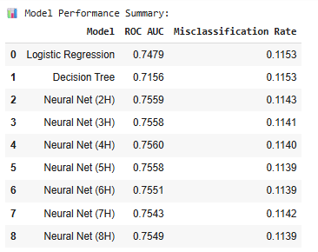
2. ROC Curve Comparison
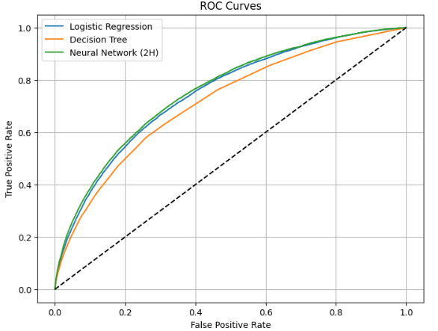

3. Top 10 Odds Ratios (Logistic Regression)
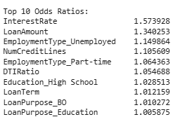

4. Decision Tree Feature Importance
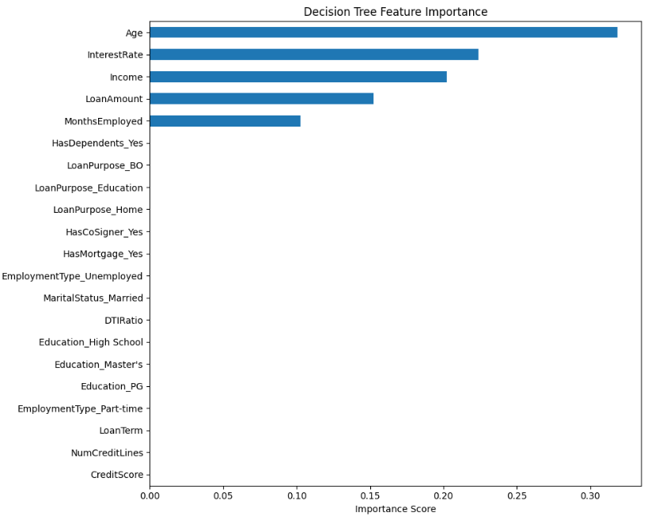
5. Correlation Heatmap

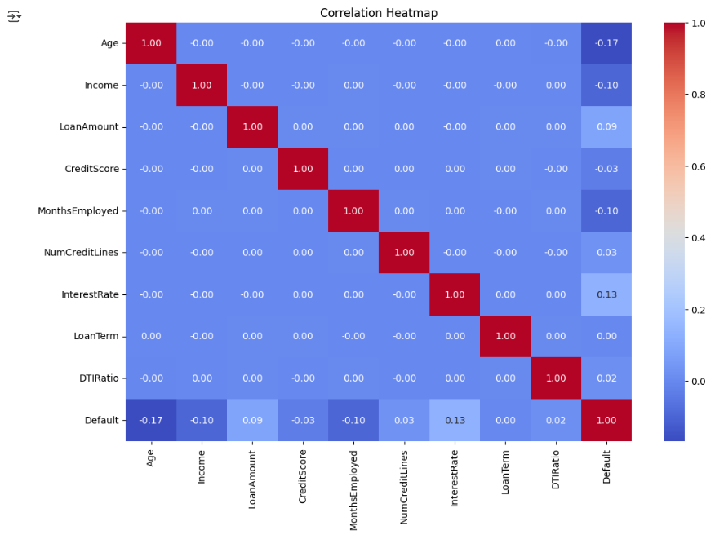
6. Shap Summary Plot

